LMe Walkthrough Script

Last updated: March 2, 2009

Preparation prior to a technical presentation: 3
Introduction 3
Technical Explanation of Repository 3
Creating and Assigning a Task via Community Manager 3
Programmer Begins .NET development work 4
Programmer Begins WDSC development work 5
Manager Needs Vision of Work in Progress 5
Environment 6
Collections 7
Programmer Checks in Work (.NET) 7
Programmer Checks in Work (WDSC) 8
QA Wants to See what has Changed 8
Promotion Request 8
Emergency Change in .NET 9
Emergency Change in WDSC 10
Resolving Emergency Conditions 11
Acknowledging Emergency Conditions 11
Promote by Condition 11
Promote by Collection 12
Repository Database 12
Security 13
Appendix: Licensing 14
Appendix: Creating and Using Assemblies 14
Appendix: Creating Related Applications 15
Appendix: Explaining Related Applications 15
Appendix: Working in Related Applications 16
Appendix: Creating a new Project 17
Appendix: Adding a Part 18
Appendix: Managing Java 18
Appendix: Managing Java Deployment 20
Appendix: Demonstrating a Java Change via Eclipse IDE 21
Appendix: Database Change Management: 22
Appendix: Filters and Viewpoints 22
Appendix: Private Versions 23
Appendix: Deployment Demonstrated 23
Appendix: Deployment Explained 24
Appendix: Integration with Ant 26
Appendix: Integration with Nant 26
Appendix: API Interface 27
Appendix: Populating Eclipse from the Repository 27
Appendix: Populating the Repository from Eclipse: 28
Appendix: Populating the Repository via Load Inventory 29
Appendix: Populating the Repository from .NET 29
Appendix: Populating .NET from the Repository 33

Preparation prior to a technical presentation:

- My Group/Application/Release is FINANCE_JB/PAYROLL/BASE (JBP)
- PDN = JBPBASPDN1 QUA = JBPBASQUAL DEV = BAUMGARTEN
- Set up the environment in ALDONM00 – have a couple items in play is nice. Some checked out to other developers. Some conditions. Etc.
- If you are not demoing CM, create a task in LMi. Use the BASEnnn as the task number. Use EBASEnnn as the emergency task.
- Sign in to the TERMINAL SERVER psg-ts box with standard joeb user profile and pw.
- Collapse the tree structure in the Locations view.
- Have the “Aldon LMe Development Lifecycle” PDF handy:
- C:\Home Work\Knowledge_Lead\UserGroup05\Aldon LMe

Introduction
- This is going to be a role-based demo where I where lots of different hats and walk you the software from the point of view of a task moving through the system.
- As much as possible, I’ll try to relate to what I know of your process and the people that are responsible for each step.
- The process I show is not intended to be an exact match to your process, but enough to give you a good sense of what the tool can do and how you could implement it to solve your problems.

Technical Explanation of Repository
- This is mostly just internal knowledge that is good to know, but sometimes people ask about how it works.
- We store the master artifacts in our inventory which is a DB2 database.
- The database can run anywhere DB2 is accepted, e.g. i5, Unix, Linux…
- We store all the versions of the artifact (e.g. INT, QA, INV, archive, private versions) in Binary Large Objects (BLOBs) in the DB2 database
- The client communicates over TCPIP with the LMe server job running on the same server as the database

Creating and Assigning a Task via Community Manager
- “Just about every best-practice model today recognizes the need for solid request management.”
- Perhaps they already have a tool that performs this function, and that’s ok. We’ll show later how they can loosely couple their tools to ours.
- Have CM already up and sign in as Joe.
- Click on Quick Ticket, Enhancement Request
- Title: Change the web site
- Status: Assigned
- Contact: Frank Dracman
- Scroll down to “Associate Aldon LM Collection”. This ties the task in CM to the work that is about to happen in LMe.
- Click on Select Release. Talk about how the Group/Application/Release structure of LM makes it easy for people to identify change areas by “business purpose”.
- Click on “Add an Assembly”
- Give the Assembly a name, e.g. BASE0014, and a description.
- At the bottom, click on Create Assembly
- If you also want to create an Lmi task, click on the Task radio button.
- Back at the main web page, type some text in the Description box.
- Under Assignees, select JOEB
- Click the GO button to create.
- Go to email and show the email to programmer.

Programmer Begins .NET development work
- Open up Visual Studio 2005
- If you are not already signed in to LMe, it prompts you to do so now.
- DC on Solution “ScreenSaver1”
- Notice the padlock on the items in the tree on the right. They are marked as “checked in”. The tool knows that LMe is version controlling this source!
- RC on the entire project, or any one item and select “Get Latest Version”. This interacts with the repo and pulls down a copy of the latest code without doing a checkout. (NOTE: This could take a bit of time if you are not working on the Terminal Server!)
- DC on SCREENSAVERFORM.VB.
- Make a change to the form.
- Notice the instant integration with LMe, a pop up box appears prompting you to checkout the item before you can edit it.
- Click on the first icon on the left on the “advanced properties” pull down button.
- Open up the project ScreenSaver1
- drill down to the LMe assembly we created above.
- Put in some comments and click on OK.
- NOTE: You will get an error message. What is happening here is that the MS/SCCI interface is trying to “handshake” with LMe by creating a temp file. LMe is seeing this file being created. It automatically added it to the repository and is trying to check it out, but the file has been deleted since the creation and is no longer there! Our next release will handle this a bit more “gracefully”.
- Click on OK to continue processing the checkout.
- Notice the automated actions in .NET:
  - The source code is copied down to your development location
  - The change you asked for has taken place
  - The padlock decorator on the icon has been replaced with a check mark.
  - The file is listed in the “Pending check in” dialog box at the bottom.
- Save your changes to the form.
- (Optional) Return to CM and show how these items are now part of the task and their current status is displayed.

Programmer Begins WDSC development work
- Open up WDSC
- Open up Aldon Resource Perspective
- Here we see the developer’s workspace laid out in a familiar explorer-like tree structure.
- The Aldon Resource Perspective makes full use of the familiar “Team” engine to interact with the master repository.
- For example, before starting on a development project, a developer might wish to refresh the entire copy in his working directory by using the Team, Get Latest.
- “Get Latest” is just like a checkout, only the item is not marked as checked out.
- Drill down to the COMPANY WEB SITE\WEB CONTENT\COMPANY\CHARITY folder
- Double click on INDEX.JSP to open it up in the editing window. Note that you are currently editing a version of the source from your local workspace.
- Make any change to it.
- Notice that the Aldon LMe window pops up asking you to check this item out.
- Give it a comment and select the LMe assembly.
- Click on OK to process the checkout.
- A Check Out function provides the most recent version of the artifact from the repository down to your workspace.
- Notice a check out mark decorator on the item.
- Because this indicator is coming from the master repository, all other developers will see that this item is checked out as well.
- Also notice the asterisk decorator on each artifact and at the parent directories all the way up the line, indicating something under here has changed.
- Also check out the README.HTML in the WEB-INF folder and make some changes.

Manager Needs Vision of Work in Progress
- At any point in the process, the manager (or any other person in the team, e.g. Developer, QA, Business Analyst, etc) might like to see the current status of all items of the application. They will use LMe.
- Open up LMe
- Here is your first shot of the main LMe “Parts” screen.
- As we discussed in the intro power point, LMe is a repository-based tool and the big window over on the right shows the parts.
- We refer to this repository as the Aldon Lifecycle Manager Team Repository. It is a "team" repository because it supports simultaneous access to individual components of the repository by multiple users - an essential element of team development.
- But not every part, that would be like taking a drink from a fire-house.
- Instead, we want to give you some powerful grouping and filtering tools to quickly show you only the parts of current interest.
- On the middle panel you see the Explorer-like view.
- We’ll work in the Locations tab for now. We’ll explore the others later on.
- As you drill down, you realize that we have structured your inventory of parts in business application style.
- You see the Group e.g. Finance. The Application, e.g. Payroll. The Release, e.g. BASE.
- This is a nice advantage of LMe. It gives us the ability to logically group together related parts regardless of their actual physical location!
- How would you envision your applications and releases showing here?
- As I click on the BASE release, notice that I am seeing all parts that make up that release. Also notice that these parts are cross-language, even cross-platform!
- Explode BASE and you’ll see that we have two further levels: iSeries for all of the objects stored in libraries on the iSeries, and locations for everything stored in directories on other platforms.
- Once again, we can group our Locations section into logical, business-oriented sections that help your developers focus more on the area of the business they need to work in, and less on the location of that master code.
- Drill down to the code that we’ve been working on and show its current status.
- RC on the part and select Properties, Properties. More proof of how much “metadata” knowledge that LM is storing in the database for us!

Environment
- Now that we have our items checked out, let’s examine what has changed here on our master inventory screen.
- Take a look at the ENVS column.
- This shows at a glance, exactly where each object lives in the structure of this application.
- Rather than show long and complex directory names, which can be confusing and sometimes rather cryptic, we simply indicate the “functional areas” where this object currently resides. Here we see “D” for development and “P” for production.
- In between, you could also define integration “I” and a QA, “Q” if this application required them.
- In LMe, these environment labels remain consistent across all objects, all types, all libraries, and all platforms.
- Notice over on the far right, everyone also now knows which developer has the item in Development.
- This is all the team really needs to know, after all, right?
- This is especially handy when
  - You have many production directories that make up your application
  - Your list of items spans multiple applications or releases
  - You are new to the company, or to this application
  - You are someone who is not familiar with the library structure.
- Does that make sense? Can you see where this would be useful in your shop?

Collections
- Another way to view the parts is via the Collections tab.
- Rather than viewing parts by their actual location as we saw in the last window, Collections provides a more “logical” grouping.
- For example, you can see here listed several tasks. This gives us the ability to collect up and manage just the parts that make up that task.
- DC on our task that was created in CM and see how it has filtered the parts list to just those objects in play for this one collection.
- SOA:
  - Another excellent example is to create a standing collection of parts that are logically grouped together as a unit.
  - This is a very effective way to combine and quickly reuse parts from multiple locations in Service Oriented Architecture development mode, for example.
- Create New:
  - You can also create collections right from here, e.g. if you are not using CM, you could create a simple collection name that matches the task name in your tool.
  - RC on Collections, New, Assembly, Task

Programmer Checks in Work (.NET)
- Now let’s go back to being the programmer.
- I’m all done with my development and unit testing and I want to get my work out of development and up into the controlled QA environment.
- Under the “Pending Checkins” box, DC on the Check In box.
- Notice the padlock decorator has returned.

Programmer Checks in Work (WDSC)
- Now let’s go back to being the programmer.
- When a team member is ready to share their work, they use the Check In function to move added and changed objects into Aldon LM team repository where it is available for Check Out by others, for testing, and promotion to production use.
- RC at the top of the list, Team, Check in
- The pop up window shows all the artifacts that have changed under the directory. If you don’t want some of them, remove the check box to deselect.
- Give a comment, associate with the assembly
- Check the “Print Report” box and click on OK.
- Notice the updates in the Aldon Status window.
- Notice the change in the decorators.
- DC on the report in the Aldon Reports view

QA Wants to See what has Changed
- Now let’s return to LMe and the QA tester assigned to this task.
- Perhaps Joe has returned to CM and changed the status to something like “ready for testing” and an email has notified the QA tester
- Go to the collections view for easiest work.
- RC on any changed item. Actions, Compare and Merge, Auto compare

Promotion Request
- Let’s summarize what we’ve accomplished up to this point with very little effort:
  - We’ve quickly built a task
  - We’ve performed analysis on the task and checked out the appropriate objects for change
  - We’ve edited and compiled.
  - We’ve promoted all changes, included recompiles, up to the QA environment.
- How are things looking to you at this point? Do you think this will map well to your needs?
- Our next step is to get the tested changes out of QA and up into Production as a group.
- We want the QA manager to tell us when the changes in this collection have been tested and are ready to roll.
- He could go back to CM and change a status and write some notes.
- He could also flag these items in LM as “request to promote”.
- This also helps some shops create a “separation of duties” that is often required for auditing standards and laws.
- Normally, this is a rather time-consuming, detail-oriented manual process. Here is another place where Aldon’s Lifecycle Manager can improve your process.
- Place a check mark in the task line to select all items in the collection.
- RC and select “Request to Promote”
- Put a comment in the comment box and click on “Post Request”
- See the “R” in the Conditions. This stands for “request to promote”.

Emergency Change in .NET
- Return to LME and notice that the item clearly states that it is now in QA
- Using the options available up top, you could also:
  - Browse the archived original source
  - Browse the current source in PDN
  - Compare the current source in PDN to the archived source to ID changes.
  - Verify that the version number of the object on this box is the same as the one blowing up on the other box.
  - Review the task used to create that last change.
  - Review all history of changes for this object.
- Does that information sound like it might be helpful at 2 in the morning?
- Your decision is that you need to make a change to the production source code.
- If you did the checkout from .NET, it will, by default, check out the QA source. This is certainly not what you want.
- We have created a special option for the emergency checkout.
- This is important for two reasons.
  - First of all, it is a special type of checkout, which we’ll see in a minute.
  - Secondly, it gives you the ability to control who has authority to this very special type of checkout.
- From LME, RC, Emergency checkout.
- The first thing that makes this special is that the emergency checkout is hard-wired to get the source code from the master production location, regardless of other copies that might be in progress.
- The second thing that makes this special is that it will allow a second checkout of an item already in play.
- Take a look at the inventory line for our object. Quite a few changes!
  - First of all, on the far right, you see the checked out developer is again listed.
  - To the left of that, you see a “Yes” flag under the “Emergency” column
  - To the left of that, you see some condition flags, we’ll come back to those.
  - Then you see that this object is currently in Dev, QA and Production.
  - Wow! All that information at a glance. Available to everyone!
  - Talk about communication!
- Now return to .NET and see that the item is once again checked out.
- Make a second round of changes and save them in .NET.
- Now return to LME and do a compare merge with INV as the reference against QUA and DEV.
- From .NET, do the check in.
- Note that it is smart enough here to check it back in to INV, not QUA.
- You can do a compare source from LME to prove this.

Emergency Change in WDSC
- Set it up:
  - In WDSC, make a regular checkout to the INDEX.JSP file.
  - Make a small change to the header text
  - Check it in to QA.
- Return to LME and notice that the item clearly states that it is now in QA
- Using the options available up top, you could also:
  - Browse the archived original source
  - Browse the current source in PDN
  - Compare the current source in PDN to the archived source to ID changes.
  - Verify that the version number of the object on this box is the same as the one blowing up on the other box.
  - Review the task used to create that last change.
  - Review all history of changes for this object.
- Does that information sound like it might be helpful at 2 in the morning?
- Your decision is that you need to make a change to the production source code.
- We have created a special option for the emergency checkout.
- This is important for two reasons.
  - First of all, it is a special type of checkout, which we’ll see in a minute.
  - Secondly, it gives you the ability to control who has authority to this very special type of checkout.
- From WDSC, repeat the check out process, only this time, select the box that says Emergency checkout.
- The first thing that makes this special is that the emergency checkout is hard-wired to get the source code from the master production location, regardless of other copies that might be in progress.
- The second thing that makes this special is that it will allow a second checkout of an item already in play.
- Take a look at the inventory line for our object. Quite a few changes!
  - First of all, on the far right, you see the checked out developer is again listed.
  - To the left of that, you see a “Yes” flag under the “Emergency” column
  - To the left of that, you see some condition flags, we’ll come back to those.
  - Then you see that this object is currently in Dev, QA and Production.
  - Wow! All that information at a glance. Available to everyone!
  - Talk about communication!
- Now return to WDSC and Make a second round of changes and save them.
- Now return to LME and do a compare merge with INV as the reference against QUA and DEV.
- From WDSC, do the check in.
- Note that it is smart enough here to check it back in to INV, not QUA.
- You can do a compare source from LME to prove this.

Resolving Emergency Conditions
- Conditions are Aldon’s way of communicating that something “special” is happening to this object.
- You can see the conditions listed right on the main inventory panel.
- Click on Conditions in the left tool bar.
- We will see one entry for each condition currently on the object.
- Show the filters. You can easily set up your own filters to look for specific conditions. Choose EmerConflict.
- The “C E” on the top line stands for “Conflict from Emergency”.
- To the right of that line, it identifies what is in conflict: the Environment column stays static through this emergency change. It is the QUA version.
- Notice the “Cnf Env Nam” column. This value will change as the object in conflict travels through the environments. If it is still in development, it will list that developer’s environment. Now, for example, it says INV.
- The “C E” is not just information, however, it is a stop sign. No other promotions can occur until this condition has been resolved.
- Should anyone, for example, try to promote the original object, that promotion would fail with errors pointing back to the emergency change in play.
- Does that sound correct to you? Make sense how we are protecting you?
- RC on the C E line and select Properties. Note what is the “condition” version and what is the “conflict” version.
- RC on the C E line and run the merge.
- RC on the C E line and remove the condition.

Acknowledging Emergency Conditions
- Notice that we have a new condition code: “A E” means that we will need someone later on to “Acknowledge the Emergency” Promotion. This is another best-practice, security-conscious, auditor-pleasing feature!
- When someone with proper authority acknowledges that event by removing that condition, information is logged for the records automatically.
- However, at this point, we’ve accomplished our goal. We’ve put out the fire in production but we’ve done it:
  - Quickly
  - Accurately
  - Safely
  - Under the watchful (AND HELPFUL) guide of the solution.

Promote by Condition
- Now click on the “Conditions” icon to switch views.
- Change Filter to “RqsPromote” and mention you can design your own filters here.
- Highlight all rows, RC and Promote.
- This clears the list because the items no longer have an “R” condition.
- Return to Parts/Collection view and show they are all in production now.

Promote by Collection
- Go to the Collections tab and see everything is nicely collected for this assembly.
- Select all of them and Promote.
- RC on any of the items View Related Data, Activity to show the full history of changes for this object that are stored in our database.
- RC on any items changed, Properties, Properties. Review the info in the tabs.
- (Optional: Return to CM and show ticket.)

Repository Database
- The reason we can accomplish this leads us to a key feature of the solution. This inventory is DATA BASE DRIVEN.
- This is a complete inventory of all of the objects you are managing in your applications.
- Many of today’s best practice standards like COBIT and ITIL state that you maintain such a list and manage it.
- Building this application inventory database is quite simple with Aldon: it is pulled right from your existing structure.
- When you define your application to Aldon, you tell the tool the directories that comprise your application.
- At that point, an auto-discovery utility will examine your structure load the artifacts into our master repository. This will then become the managed repository from which all version control will occur.
- We can store this repository on the iSeries, Linux or AIX. Regardless of where it is stored, all access will be driven via LMe.
- Storing both the metadata about the repository and the repository itself of all parts across all applications of your enterprise onto one system greatly simplifies security, backup, and recovery as well!
- We store a wealth of information for each entry.
  - We know where the object lives in the production environment.
  - We know where the master source code lives.
  - We know how this object relates to other objects in your application because we also capture cross reference information here.
  - We know the object type and the proper create command to use.
  - We know the proper parms to pass in to the create command for this object. Even if they are not the default parms.
  - We know the proper library list to be used for the compile.
- Later, as you use the product to make changes, we will also create and capture a unique version number for that object’s change.
- This version number helps prove that you have the proper version of an object at all locations, and that that object was placed there by our solution. A tremendous aid to security management and audit verification!
- We will also capture here all tasks for which this object was changed.
- Having all of this knowledge in the solution means that the solution can bear more of the weight of your standard development process. A weight that used to be borne by your developers. This not only increases their efficiency, but, by extension, increases their accuracy as well!
- The Aldon LM(e) server is now available for the following hardware/operating system environments:
  - IBM i5/p5 hardware – i5/OS Operating System, Red Hat Linux Operating Systems
  - Intel-based hardware – Red Hat Linux and SuSE Operating Systems
  - AIX is next.

Security
- We have a free web-based security administration tool called Aldon Security Server.
- It is used for license management, user authentication and action authorizations
- See http://psg-lmx:8080/aldonsecurityservice/index.do
- Aldon uses a very effective and efficient role based method to control security.
- One easy way to design User Classes is by the role of the user.
- offering a fine-grained control over the data and applications users are permitted to access and the level of those privileges
- managers can easily define one user under multiple roles, with different access privileges for each.
- Managers are then able to determine the roles and responsibilities in the development process and set hierarchies of roles, by group, department, individual, or through inherited roles, greatly improving overall security

Appendix: Licensing
- There are two types of licenses, named and concurrent.
- Named means that you are reserving this seat for the sole use of one individual. If that person is not using the seat, it is not being used by anyone. When ever this person wants to use their seat, it is always available.
- Concurrent means that anyone that is in the concurrent user pool (more on this later) can use that seat, but only if they are the first one there. If that seat is already taken, they can’t get in until it is open again.
- The Security Server is managing the LMe licenses.
- Here, you specify how many Named seats you own and how many concurrent seats you own. You enter in a license key to activate that number.
- In the Security Server, you “name names” and set up their authority.
- On each name, you select “named”, “concurrent” or “none”.
- Security Server will not let you select more “named” or “concurrent” choices that the number of seats you own.
- “None” is useful if you want to create people, but not have them counted against your total seats. For example, Sally goes on maternity leave and you hire a contractor to fill in for her. Change Sally’s entry to “none” and temporarily give her seat to the contractor.
- It is possible to buy more than one concurrent use license. In this mode, if one concurrent user was already in that seat, you’d have another one available if another concurrent user wanted to get it.
- At this point, there is no provision for groups of concurrent users.
- DM Licensing
- DM licenses are also managed by the Security Server.
- DM has a client program and a server program.
- The server portion is included into Lmi or LMe.
- The client portion is what is chargeable. It is what gets installed on the target platform to receive the deployments.
- The Security Server makes no distinction on whether the DM license is on the local box or the remote box. So, if the client wishes to deploy to the development box where Lmi/LMe is hosted, (e.g. to the IFS), then you must have a license for that box.

Appendix: Creating and Using Assemblies
- Assemblies are collections of parts
- Assemblies can be nested to any depth
- An action applied to an assembly is applied to each nested assembly and each of its parts independently
- You can have three types of Assemblies
  - Collection Assembly
    - Represents a logical collection of parts, independent of their physical location
    - Task Collection: all of the parts that are associated with a task in Lmi or LMe
    - User Defined: Represents a logical collection of parts. It’s the user’s privilege to define the relationship. Attributes may be predefined and used as desired to distinguish relations
  - Location Assembly
    - You give it a path designator to a directory location, e.g. a simple folder, or a collection of other sub-directories.
  - Java Package
    - Holds all the items for a java package.

Appendix: Creating Related Applications
- Let’s create a new PTF structure under our V2R0 Base.
- Click on Set Up, Release Configuration.
- Drill down to Payroll, Base.
- RC on V2R0 Base and select New, Delta.
- Version: PTF2
- Owner: aldondbi
- Sibling of other child releases to this parent.
- Allow promote to parent.
- Leave all other tabs and options as is (we will NOT be creating this release to manage Lmi objects).
- Click OK to make the release.
- You should now see PTF2 as a “sibling” delta release. It is NOT active.
- RC on it and interactively activate it.
- Now return to the Parts view and hit refresh.
- Navigate down to PTF2 and explore the structure.
- Notice that I have all of the items shown from my parent Base Release 1.0, but the environments column is empty. None of these items shown are presently in this OPENPTF release yet. Make sense?
- (PRIVATE NOTE: before you can check out any of the IDE project structures such as the .NET or WDSC artifacts, you need to manually create a “static path” on your C drive and define that to your development environment. )
- YOU CAN CHECKOUT any of the Documentation since that structure doesn’t have an associated IDE, its path gets automatically created by LME.
- Delete the structure by going back to Set Up, Release Configuration.
- Drill down to Payroll, Base, PTF2
- RC and delete. (Nothing must be checked out for this to work).

Appendix: Explaining Related Applications
- Show the related structure under Payroll.
- V2R0 has been designated as the base. It holds the entire master source.
- Now explode out PTF1 and the Documentation location.
- PTF1 was created as a “delta release” with just a few simple mouse clicks by the administrator.
- It duplicated the entire structure and the entire inventory of parts, but not the source code.
- As such, we say that the source code for these parts in PTF1 are non-resident.
- Notice now the “Res Rls Ver” column. This shows you where the resident source code for this part resides.
- This not only makes it extremely easy to create new structures (e.g. branches), it also makes it very easy to spot exactly what you have and have not customized for this release.
- Notice the A/D column. This is the Ancestor/Descendent indicator. A “+” means that copy of this same part exists in a descendent (child) release. A “-“ means that it also exists in an Ancestor (parent release).
- You have options inside the release to NOT allow any changes, e.g. to lock it down preventing any future development. However, the master source is available to be checked out for modification in one of its descendent releases.
- You also have the option in a descendent release to allow “promote to parent”. This is used when you have completed the work you wanted to do in the child and you now want to push that work back up to the parent level, e.g. folding the work from a “long term” project up to the day-to-day release.

Appendix: Working in Related Applications
- Notifying Releases
  - By default, the parent and child are tied together. The Parent becomes the “notifier” release.
  - If the same part exists in both the parent and the child, and a change is made to the parent, a notification is generated on the part in the child in the form of a conflict that must be managed.
- In my structure, V2R0 Base is the top parent grandfather, V2R0 PTF1 is the father and V2R0 OPENPTF is the grandson.
- Just to keep it simple, we’ll work in the “SimpleHelloWorld” project. Show that it exists in all three versions.
- We want to make a change. To keep it simple for our developers, we’ve created a “working release” called OPENPTF. Periodically, all changes that are accumulated here will be smoke tested and pushed up to the PTF level. As needed, these PTF branches will also be locked down and released, and a new PTF parent to OPENPTF will be created.
- Say that the developer needs to make a change to the HelloWorld.java part. Instantly he can see that this part is resident in the OPENPTF and that his changes will be added to the prior ones.
- Check out HelloWorld.java. The source code goes to my development area C:\FINANCE_JB\Payroll\V2R0\OPENPTF\SimpleHelloWorld.
- Edit this now however you wish. I could actually DC here and make a simple change via Visual Studio (my default java editor).
- Check it in and promote all the way back to production.
- Now let’s say that it is time to pull together all resident changes in OPENPTF and push them up to their parent, PTF1.
- Click on View, Residency, Show Resident Parts.
- It shows only those parts (and their containing directories) that have been modified.
- Click only once in the top path, then on Actions, Promote to Parent.
- Notice that the “P” has shifted from under the ENVS environment over to the RL column and the “-“ is now gone. This object is no longer in the child release, it is now in the parent of that release.
- Now let’s go back up to the grandfather release, Base, and make a change to the version that lives there.
- Check out, change and check in HelloWorld.java.
- Now if you look in the PTF1 child release, you will see that HelloWorld here as a Condition of C (conflict) and Code of R (related app). Before HelloWorld here can be checked back in, this conflict must be resolved.
- Click on the Conditions icon and filter by RelatedConflict.
- RC on the part and show the compare features.
- RC on the part and remove the conflict.
- Return to the parts window and proceed with checkin and promote.

Appendix: Creating a new Project
- If the folder does not already exist on your PC create. In this case, I’ll use folder C:\WebSmart Development
- In LMe, setup the external project
  - Select Setup, External Setup
  - Click on IDE Projects, then the “New” button
  - Give the project a name, e.g. WebSmartILE
  - Navigate down to the appropriate Group/Application/Release and select it
  - If the “Include Aldon LMi Data” box activates, check it.
  - Under Path Designator Assembly, select “Assign the next available path designator number”.
- In LMe, setup the client development environment
  - Select Setup, External Setup
  - Select Environments, Development
  - RC on the development environment, E.g. JBLaptop
  - Select Environment Paths
  - Select the Client Paths tab
  - Click on New
  - Pull down the Path Designator box and you should see your new path, e.g. 106:WebSmartILE
  - In the Environment Path, click browse and select your development location, e.g. C:\WebSmart Development
  - Click Save and Close.
- Now you can add the parts (see next appendix).

Appendix: Adding a Part
- In the Locations explorer tree, position to a Group, Application, Release where you want this part to be added.
- RC, New, Parts
- Chose your development environment, e.g. your laptop.
- The Add Parts function can only create parts from files in paths associated with an existing development environment.
- The box on the right will show the current contents of those paths in your development environment. Select either the entire directory structure, or just the individual part(s).
- As files are processed during an Add Parts operation, files with file extensions in the list of excluded file extensions are automatically excluded.

Appendix: Managing Java
- In LMe, a “part” might actually contain multiple “items” under the covers. The inventory will only show the part, but under the covers, it knows about all of the items.
- For example, AccountBalance.java would be the primary part, but could have the following items:
  - AccountBalance$1.class
  - AccountBalance$2.class
  - AccountBalance$3.class
- When we load the release, we
  - Registers part for each java file in the package
  - Registers a ‘.java’ item for the source and one or more ‘.class’ items for the object(s)
- When we check out or promote the AccountBalance.java primary part, all four of the items are managed as a unit in an “atomic” fashion: they are either all moved, or none of them are moved.
- RC on “HelloWorld.java” and then Properties, then Instances. Show how we know of the java (primary) and the generated class (build result).
- Java Packages:
  - Click on the “Package” tab under the LMe explorer window to see all of the packages available.
  - Each package holds all of the items for that package and they can be managed as a group.
  - To control this:
    - Click on Setup, External Setup, Environments, Development.
    - RC on JBLapTop, Properties, Advanced, Client Environment.
    - Identify Java Class Files
    - If checked, whenever a Java file is checked in from this environment, the file will be scanned to identify the Java class files defined in the Java file.
- Java Options for Check In:
  - To control this:
    - Setup, Release Configuration and drill down to the release level.
    - RC on release, Properties, click on the Release tab
  - Java check in option: NONE:
    - Depends on the setting for “Identify Java Class Files” in each programmer’s development settings (see above).
    - Identify Class Files is Yes and Check in Option is NONE:
      - java files are scanned to identify all classes referenced in the java file.
      - all identified class files must be found and added as items to the java part in order for the check in to be successful.
      - parsing will add all class files found during the parsing process.
    - Identify Class Files is No and Check in Option is NONE:
      - there is no special handling of java files.
      - The java part is treated as a regular multi-item part if java & class files were loaded.
- Java check in option: COMPILE
  - Java dependencies are established/updated
  - “Release class paths” tab identifies class path dependencies if external to application directories
  - The java files selected as part of the check in and all dependent files are submitted together to the Java compiler
  - Executes JAVAC command
  - If the compile action completes successfully the java part is checked in; if not successful the part is not checked in
  - When a java part is checked in, it may not have any class files defined; compile will add all class files during the compilation process. It will also remove class files that are no longer referenced by the java source.
- Java check in option: SCAN ONLY
  - Scans the java source to find the package statement only so that the part may display on the Package view.
  - Class files are not managed when “scan only” is used.

Appendix: Managing Java Deployment
- Important Questions to Ask!
  - What IDE are you using?
  - Builds:
    - Who performs the builds?
    - What build tools are you using?
    - Where are the builds performed?
    - When are the builds performed?
  - What gets deployed?
  - Development vs. deployment based
  - How are you managing this now?
- What to manage?
- Source or Class only
- JARs only (for java specific applications)
- WARs or EARs only (for web specific applications)
- Any combination of above
- IDE Project files
  - ‘.project’, ‘.websettings’, ‘.classpath’, ‘.website-config’, etc.)
- All other resources
- IDE based development
  - Directory based vs. repository based
  - Requires management of project files
- Compile requirements
  - If performed on Aldon LM(e) server, JVM and requisite files must exist on server for successful compilation
- Audit requirements
  - Internal
    - Development activity
  - External
    - Sarbanes-Oxley compliance
- You can NOT have LM deploy what you are not managing in the inventory.
- You can manage source only, class only, JAR, WAR or EAR only, or any combination of the above.
- Choice 1: Deploy source and classes (no build results exist)
  - Straightforward management in Aldon LM(e)
  - Classes and/or source are deployed directly
  - No creating of builds
  - Some web application server instances may need to be bounced to pick up the new deployment.
- Choice 2: Deploy source, classes and build result (classes optional)
  - Build results are managed, archived and deployed in Aldon LM(e)
  - Build results could be managed in a different path designator from the source and classes
  - Builds are performed manually or you could use Before Each Event Trigger on Check in if using server development environment
  - Complies with IBM recommended solution for creating WARs and EARs
- Choice 3: Deploy source and classes. Use post deployment command to automate the build
  - Builds are performed automatically on the target – commonly through the use of ANT
  - Build results are not managed, archived or deployed in Aldon LM(e)
  - Complies with IBM recommended solution for creating EARs and WARs
- Choice 4: Deploy source only and use post deployment command to automate compile/build
  - Compiles/builds are performed automatically – commonly via ANT
  - Compile/build results are NOT managed, archived and deployed in Aldon LM(e)
  - Complies with IBM recommended solution for creating EARs and WARs
  - Parts are being managed as single-item .java
  - No management of .classes or .jars
  - build.xml file is the configuration file that dictates how the build is performed. It is managed by LM(e).
  - .java and build.xml files are deployed
  - Deployment Profile contains a post installation program (i.e., build.bat) that is used to perform the build using Ant
  - build.bat contains Ant command and path to build.xml file
  - build.bat must exist on deployment target
  - 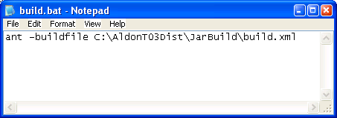

Appendix: Demonstrating a Java Change via Eclipse IDE
- Start up the Java EE Eclipse 3.4 “Ganymede” IDE
- RC on the project name, select Run As, Run on Server.
  - This starts up the Apache Tomcat server on my laptop and opens up the application in a Firefox browser.
  - Note that the app is opened up from “localhost” which is my development workspace.
  - Point to the copyright notice in small print at the bottom. This is what needs to be changed.
  - Leave the website up for later use.
- Navigate down the tree to Java Resources: src, com.aldon.tm.ui.resources and DC on tmweb.properties.
- DC on tmweb.properties to edit it. As you start to make the change, it will prompt you for checkout.
- Make the change and save it.
- Switch over to LM and show the object checked out under src.com.aldon.tm.ui
- Return back to the web site and reload. Show the change in development.
- Now ready to promote it.
- Return to Eclipse and check the item back in
- Return to LM and promote the item up to production.
- Show how it will deploy it to deployment profile web-prod. This puts it up to the PSG-TS server.
- Return to the browser and change “localhost” to psg-ts, leaving the rest the same.
- Show that the web site has our changes in it.
- Password/profile is “tmdemo”.

Appendix: Database Change Management:
- Aldon is NOT a full DB change management solution like Embarcadero or Quest.
- However, these tools do not provide full SCM either, so most advanced users realize that both are necessary.
- We do not manage the data, the schema, and the relationships.
- We DO manage the scripts, the triggers, the stored procedures and other such tools that work against the data. We can manage these because they are stored at the file system directory level.
- Once these scripts are deployed, the Deployment Manager set can be taught to execute a post install command(s) to execute the scripts.
- For example:
  - Open up Visual Studio
  - Check out a stored procedure and associate it with a task.
  - In VS, you can RC on the item and “Run” to do a unit test.
  - Now check it in.
  - Optionally, DM can deploy this stored procedure (and anything else associated with the task) to the target and even run a command after the install to run the script.

Appendix: Filters and Viewpoints
- Filter: controls the data in the item window.
- They are easily definable by the end user. SQL based selection criteria.
- Viewpoints allow users to customize columns (re-arrange, add, remove) and save the view as a private viewpoint.
- Viewpoint Sets are ways to make collections of filters and viewpoints.
- Unlimited number of custom filters and viewpoints may be created per user.

Appendix: Private Versions
- LM(e) provides many powerful version control tools.
- One of them is “Private Versions”.
- This feature enables a developer to upload a copy of his development version back to the repository for storage on the server.
- This is NOT a check in! This version is still checked out.
- It is just a nice way to save work in progress so if your laptop dies, your work is safe and backed up on the server.
- A private version is stored in the repository on the server, but is not available for check-out or get-latest.
- It is deleted when the part is checked-in without leave-checked-out.
- Check out an item and make some changes to it.
- Now RC on the item, Private Version, Checkpoint.
- Put in some comments and then OK.
- RC on the item again Private Version, History.
- You can see the various back versions. You can compare, delete and more.
- You can even restore a particular version back to the development environment from whence it came.
- By default, the private version is deleted when you check in your copy.

Appendix: Deployment Demonstrated
- I have two deployment profiles configured on my laptop, Warehouse_QA and Warehouse_INV.
- Both of these are associated with the Base release of the Warehouse application.
- One is automatically associated with the QUA environment and one is to the INV environment.
- Both are set to target the PSG-CM-DEMO windows server.
- On that server, they will be installed to c:\temp\joeb\QUA and \PDN.
- I also have a post-install command on the deployment that will send an email to me confirming that the deployment has finished.
- Before the demo, start up the terminal server to PSG-CM-DEMO and sign on as joeb
- Open up the windows services on this box and look for one that should be running called “Aldon Lme Deployment Wrapper”.
- You might also want to delete the entire structure under \QUA and \PDN, not only to keep things tidy, but to demonstrate that we will create the paths if they are missing on the target.
- Once you deploy, click on the Deployment Sets to show the current status.
- Click on the set and view the log for that set.
- Once all has gone to a successful install, switch over the server and open up the target file. See the new items installed.
- The zip file and the manifest file is stored in c:\program files\aldon\aldon LM 5.1\Distribution\Deployment Packages
- These give lists of what has been deployed and what was replaced for quick recovery.

Appendix: Deployment Explained
- DM operates in a client/server mode. The Server is the iSeries development box, the client is any target (iSeries or not) that can run a JRE 1.3 environment.
- Deployment steps:
  - DM server attempts connection to the DM client over TCPIP connection
  - DM server connects over specified ports, sockets, verifies client name, etc to ensure secure connection
  - DM server pushes the changed artifacts to the client
- Deployment Set: A container of information defining what is to be deployed and where it is to be deployed
- Deployment Profile: A pre-defined element used to create a deployment set. Defines what, how, when and where for the deployment set
- QUICK TIP: A deployment profile may be set as an attribute of the “to” environment; then deployment will be initiated seamlessly without the need for user intervention.
- A deployment profile may be set on any release environment record. When parts are checked in/promoted to this environment, the associated deployment profile will initiate deployment and a deployment set will be created.
- Quick Tip: If the “Allow override” and “User can choose whether to do the deployment” fields are NOT checked, deployment will be performed automatically when checking in/promoting to this environment.
- Four steps to deployment:
  - ADD - Creation of a set manually or automatically
  - PREPARE - Selection criteria is applied and full path is constructed
  - DEPLOY - Files are packaged (zipped) and package is sent to DM Client over a secure TCPIP link
  - INSTALL - Package is unzipped and files are installed. Any prerun or postrun commands associated with the set are executed.
- ADD
  - Manually
    - From LMe, RC on a single part, a selection of parts, or any collections of parts (e.g. an entire task or an SOA collection for example,
    - Select Deployment, Deploy.
    - Select the from environment where the artifacts should be deployed from and the Deployment Profile that dictates where the set is going, how and so forth
  - Automatically
    - During check in or promote, deployment can be automatically invoked via the release configuration settings.
- PREPARE
  - Applies the selection criteria and constructs the full installation path for the files that will be deployed.
  - The selection and path information is provided by the selected deployment profile.
- DEPLOY
  - On the receiving computer, the package has been placed in the Packages Location defined during setup of the DM Client.
  - The PnnnnnnDEPLOY.zip file contains the files to be installed.
- INSTALL
  - Files are installed on the receiving computer.
  - If the installation path contains any non-existing directories, they will be created during the install.
  - The Pnnnnnn.zip file contains the archive copies of files that are replaced during install.
  - The Pnnnnnn_MANIFEST.txt file contains a list of files installed and/or deleted.
- DEPLOYMENT PROFILE
  - Controls each deployment action
  - Specifies last auto-start step (add, prepare, deploy, install)
  - Consists of:
    - 1 or more Targets
    - Optional pre and/or post installation command string(s)
- DEPLOYMENT TARGET
  - Consists of:
    - A single Location
    - 1 or more Mappings
- DEPLOYMENT MAPPING
  - Specifies:
    - The selection criteria applied to candidate parts
    - The target relative path for each installed file
- DEPLOYMENT LOCATION
  - Consists of:
    - The root/top-level installation path
    - 1 or more Computers
- NOTES:
  - At this time, LMe deployments and Lmi deployments are completely separated and there are no links or communications between them.
  - So, while they are atomic in themselves, they are not atomic together. In other words, if a task contains both distributed and native artifacts, it will require two disparate promotions that have no connection between them.
  - When you deploy all of the objects in an assembly from LMe and some of the items are iSeries, a single batch job is submitted to the iSeries to kick off the deployment there. The default live deployment profile on the Lmi release environment is used.
  - It must be a live deployment profile because these profiles are “hard coded” with the settings for the deployment profile, the targets, etc. This is necessary because, at this time, LMe cannot prompt for deployment settings on LMi.

Appendix: Integration with Ant
- We can automate the build process in LMe by using batch files that execute ANT scripts.
- You just add a single line of script to the end of the deployment to run ANT which does the build.
- Choice 4: Deploy source only and use post deployment command to automate compile/build
  - Compiles/builds are performed automatically – commonly via ANT
  - Compile/build results are NOT managed, archived and deployed in Aldon LM(e)
  - Complies with IBM recommended solution for creating EARs and WARs
  - Parts are being managed as single-item .java
  - No management of .classes or .jars
  - build.xml file is the configuration file that dictates how the build is performed. It is managed by LM(e).
  - .java and build.xml files are deployed
  - Deployment Profile contains a post installation program (i.e., build.bat) that is used to perform the build using Ant
  - build.bat contains Ant command and path to build.xml file
  - build.bat must exist on deployment target

Appendix: Integration with Nant
- NAnt is the Ant equivalent for .NET artifacts.
- I found this link http://ant.apache.org/antlibs/dotnet/index.html and http://nant.sourceforge.net/ which talks about NANT, something called MSBuild and some other stuff.
- (from Dale):
  - I've not seen any issues with creating batch files to be
used/specified in post-deployment commands to employ NAnt
for build processes.
  - I've been able to create a sample bat that will execute a build. During
the process, I've included use of the command line processing for LMe to Checkout the *.exe for the build, rebuild the *.exe and check-in the result.
  - I've also located a gui wizard for NAnt that is very useful in debugging the builds (http://www.nantwizard.com/index.php).
- <project name="NAnt Build" default="build" basedir=".">
<description>Test of NET build files.</description>
<property name="debug" value="true" overwrite="false" />
- <target name="clean" description="Remove all previously generated files.">
<delete file="\NANT_Build\ITG\build\ScreenSaver1\bin\Debug\ScreenSaver1.exe" failonerror="false" />
<delete file="\NANT_Build\ITG\build\ScreenSaver1\bin\Debug\ScreenSaver1.vshost.exe" failonerror="false" />
</target>
- <target name="checkout" description="Check out the build result to Aldon LMe">
<exec program="/NANT_Build/ITG/scripts/checkout_build_result.bat" />
</target>
<target name="build" description="Compiles the source code" />
- <target name="checkin_deploy" description="Check-in the build result to Aldon LMe">
<exec program="/NANT_Build/ITG/scripts/checkin_build_result.bat" />
</target>
</project>

Appendix: API Interface
- Our API has a Microsoft COM interface so almost any language that runs on Windows can call it.
- We also have a C++ and a java interface to aldoncs but I don’t know if we are going to publish this interface though and make it available to the public. So far it is for internal use only.
- Ability to checkin/checkout from Linux (called LMAPI for LINUX support) is scheduled to be released in LMe v5.2. This is scheduled to go GA the 2nd quarter of 2008.

Appendix: Populating Eclipse from the Repository
This technique is used when you have a project in LMe’s inventory that you want to download into a developer’s personal eclipse workspace.
- Open up your eclipse tool (e.g. RAD, WDSC…) and the Resource perspective.
- If you are not already seeing the “Aldon Repository” view, use Window, Show View, Other then Aldon Lifecycle Manager and Aldon LM Repositories.
- Explode the list and drill down to the desired project.
- Select “Add to Workspace” to add it to the default workspace. Select “Add to Workspace at” to have more control on where it gets added.
- This puts the project on your screen and connects you to the repository in LMe, but nothing is in your eclipse workspace yet.
- RC on the project header in eclipse and select Team/Force Get Latest.
- You should see the “< >” symbols disappear from before the project name. You should also see the artifacts appearing in the workspace directory on your PC.
- NOTE: this will also add the path to this IDE project in your LMe Developer Environment, so if you checkout directly from LMe it will work just the same.

Appendix: Populating the Repository from Eclipse:
This technique is used when you have a project in eclipse that you want to upload into LM’s inventory under a release.
- It is usually more clear when you do this from the Resource Perspective
- RC on the project, Team, Share Project
- Choose Aldon LM from the repository list and Next
- Choose Hierarchical file system (LMe), Next
- You may need to wait a bit at this point and on future screens as it interacts with the LM server.
- Drill down to the release and Finish. This creates the IDE project shell in LM inventory, but none of the contents are there.
- RC on the project parent directory (to select everything underneath it) and select Team, Add.
  - This uploads all of the contents to LM and places them under the IDE project shell created above.
  - All of artifacts in LM will be listed as checked out and in Dev.
  - Parse the java code to determine the classes and package.
- You should see the full inventory listed now in LM.
- From the IDE, RC on the project name and Check In.
- If you get a failure on the check in (AFF1401 and AFF1454) that says something about how it can’t find the path to the class, it is because your project is defined in such a way as to place the class objects in a separate location.
  - You may notice that the class folder is not present in the LMe inventory structure. This is because of two things
    - We set up WDSC Window Preferences, Team, Ignored Resources to ignore .class
    - We set up LM to parse the java code at check in/add to identify the class artifacts and to manage both the java and the classes together in one part (see appendix Managing Java above).
  - We need to manually create the missing directories in the inventory
  - Open up the structure containing the class artifacts in Eclipse.
  - Open up the structure in LMe
  - RC on the parent directory that is missing the class directory
  - Create the class via New, Assembly, Directory
  - Create the package directory under class the same way
  - RC on the package directory and create the package via New, Assembly, Java Package. Click ok to accept defaults.
  - You should now see the same structure in LM as you do in Eclipse.
  - Now you can check in from Eclipse.
  - Verify that you have the classes by finding a java item and looking at its properties. You should the corresponding class in the proper directory.

Appendix: Populating the Repository via Load Inventory
The preferred method of populating the inventory is from the IDE itself. If, however, there is not LM interface to this IDE, you will load the file structure in from the server directly.
- From LMe, Setup, Release Configurations
- Navigate down to the release you want to load into.
- RC on the release and Load Inventory
- Click Browse on the “load from path”. NOTE: this only gives you vision to the root directory of the server upon which LM is loaded. If you want to get a structure from another server, you’ll need to somehow mount a shared drive to that location.
- click help.

Appendix: Populating the Repository from .NET
- In .Net 2005, select the solution and click File→Source Control→Add Solution to Source Control.

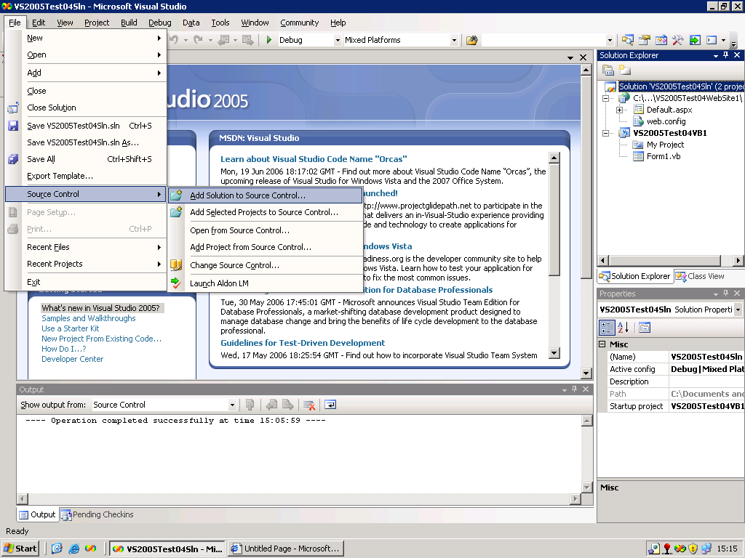

- In the window below, click New to create a new Aldon LM(e) IDE Project.

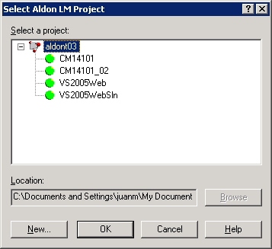

- Select the Release where the IDE project will reside in and click OK.

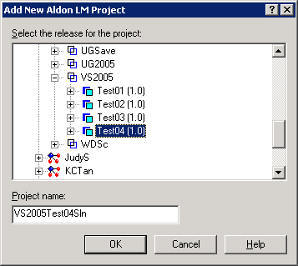

- Select the newly created Aldon LM(e) IDE project and click OK.

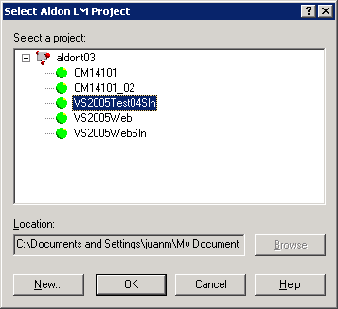

- All files in the solution including the projects will not be registered under Aldon LM(e) source control and should be ready for check-in.

Appendix: Populating .NET from the Repository

- The “Open from Source control” should be used to obtain the Solution and Project/s from the Aldon LM(e) repository. The following screenshot illustrates the contents of the Aldon LM(e) repository.

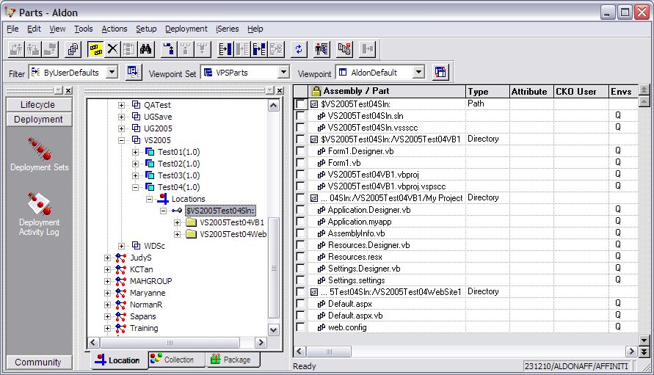

- Before going into the VS .Net 2005, create the folder where the solution will reside. In this example the VS2005Test04Sln folder was created in C:\Documents and Settings\juanm\My Documents\Visual Studio 2005\Projects.

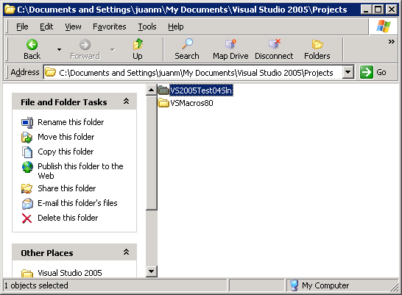

- In VS .Net 2005, click File→Source Control→Open from Source Control.

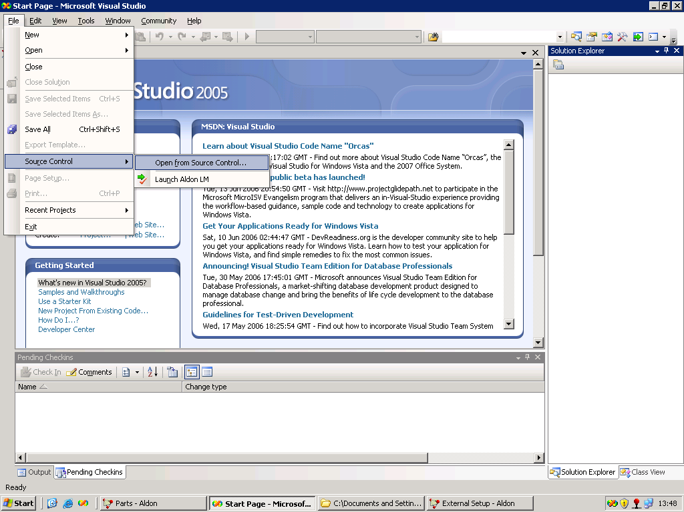

- Select the Aldon LM(e) IDE project created for the solution.

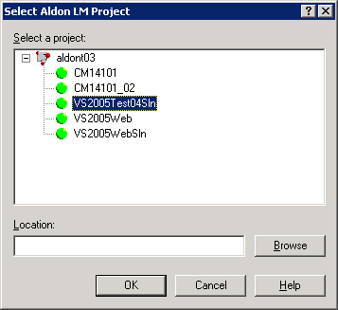

- Click the Browse button in the previous window and locate the folder for the Solution. This is the same path as created in step 1.

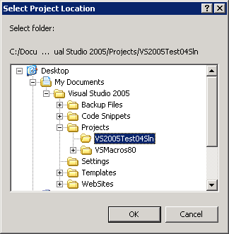

- With the proper Aldon LM(e) IDE project selected and the path specified, click OK.

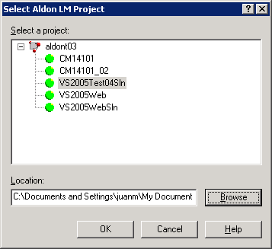

- Select the solution file and click Open.

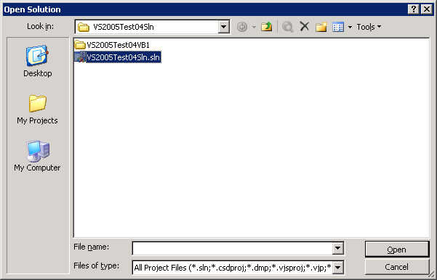

- The SCCI interface will now get the solution file and all the projects that belong to it and should be ready for checkout from Aldon LM(e) through .Net 2005.

